**Differences between Document and Window Object**

**Document Object;**

The document object represents a web page that is loaded in the browser. By accessing the document object, we can access the element in the HTML page. With the help of document objects, we can add dynamic content to our web page. The document object can be accessed with a **window.document**or just**document.**

**Some methods of document object ;**

**document.createElement(element)*//Create an HTML element***

**document.removeChild(element)*//Remove an HTML element***

Window Object ;

The window object is the topmost object of the DOM hierarchy. It represents a browser window or frame that displays the contents of the webpage. Whenever a window appears on the screen to display the contents of the document, the window object is created.

Some methods of window object ;

**window.open() - open a new window**

**window.close() - close the current window**

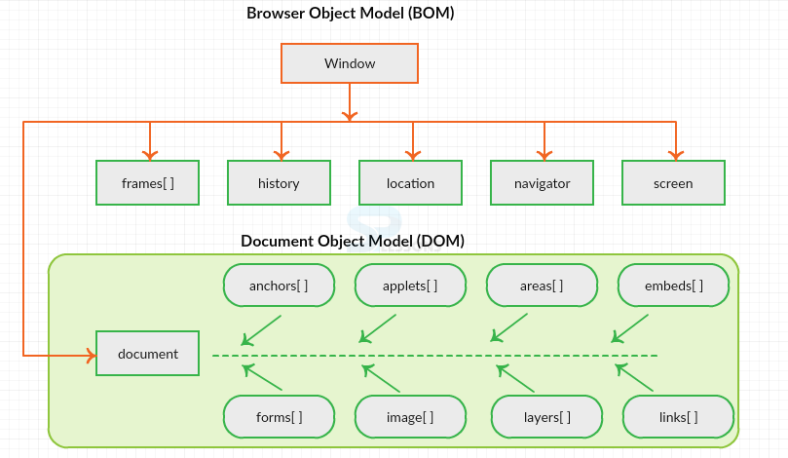

Figure 1

Difference between Windows and Document object

|  |  |  |  |
| --- | --- | --- | --- |
| |  | | --- | | Windows Object |  * It represents any HTML document or web page that is loaded in the browser. | |  | | --- | | Document Object |  * It represents a browser window or frame that displays the contents of the webpage. |
| * It is loaded inside the window. It is the object of window property. | * It is the very first object that is loaded in the browser.It is the object of the browser. |
| * All the tags, elements with attributes in HTML are part of the document. | * Global objects, functions, and variables of JavaScript are members of the window object |
| * We can access the document from a window using the window. document | * We can access the window from the window only. i.e. window.window |
| * Properties of document objects such as title, body, cookies, etc can also be accessed by a window like this window. document.title | * Properties of the window object cannot be accessed by the document object. |

Thank You